Andre Hardy– Project 4-3

4. Click Pause updates for 7 days. What warning are you given?
A: “Your device won’t be up to date whole updates are paused.”
7. Expand each area and select one update to review. Read through the information on the update. How detailed is this information?
A: This information is not detailed as it only explicitly state the name of the update and nothing more
12. Read the information under Pause updates. Why would you select this option?
A: You may want to pause updates when you are unsure how critical systems will react to them and you want to test this update in a controlled manner
13. Click the down arrow under A quality update includes security improvements. It can be deferred for this many days. How many days can you defer security updates?
A: You can defer security updates for up to 35 Days
18. Now perform a Quick scan of the most essential files. Click Scan now. Depending upon your system, it may take several minutes to complete. What was the result of the scan?
A: 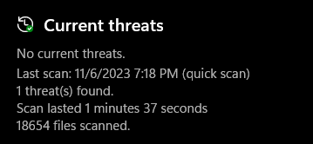
20. Read through the details of the options. Are there any that you would change? Why?
A: I would not change these settings as they appear to be best practice security settings.

